ScreenShots

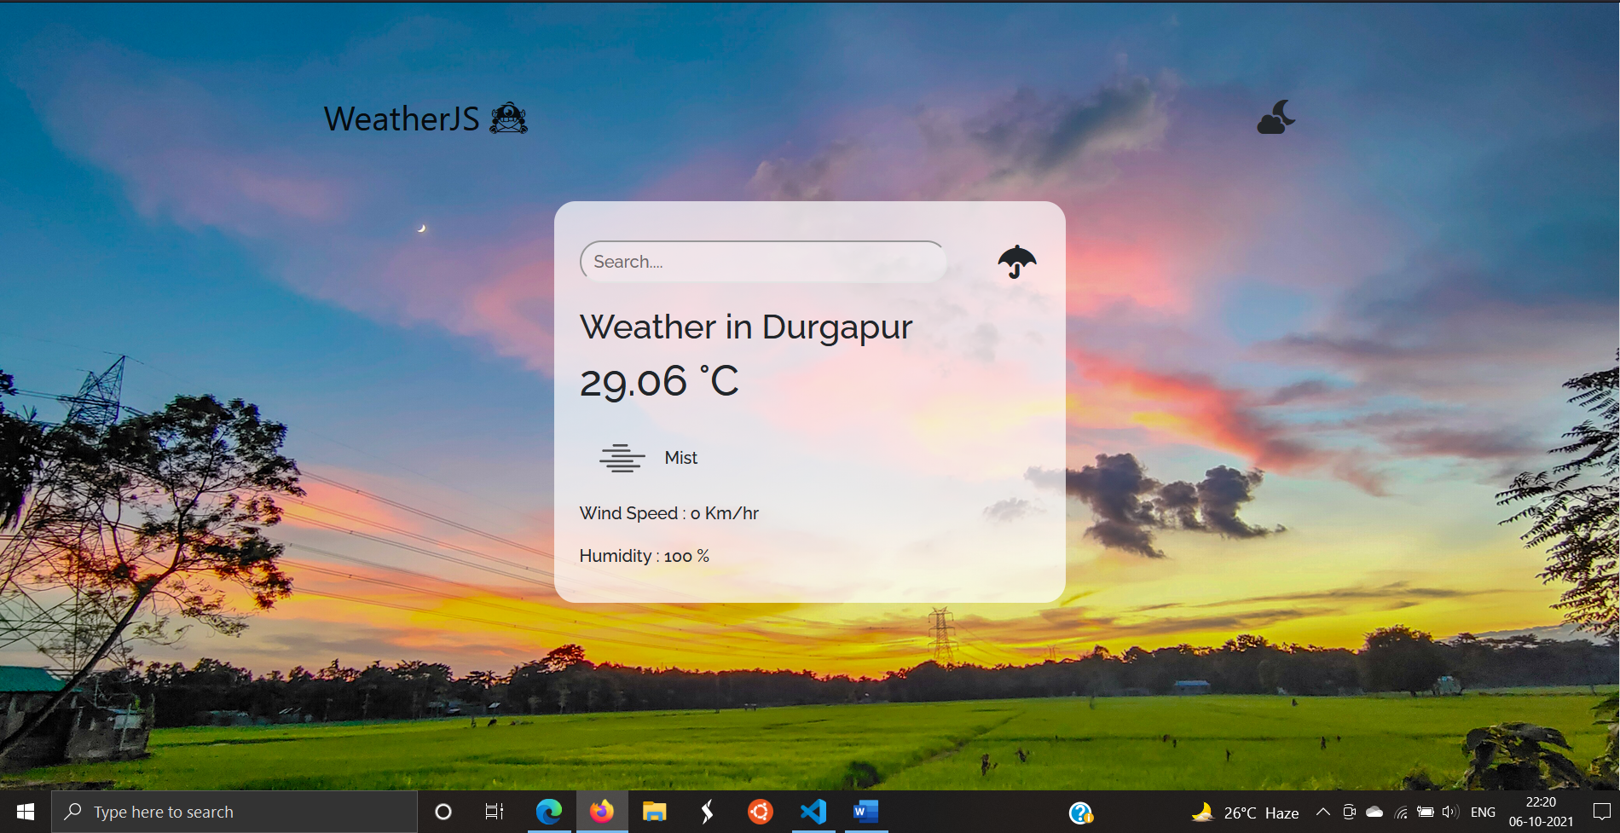

Get weather by searching places in the search-box and chick the umbrella button

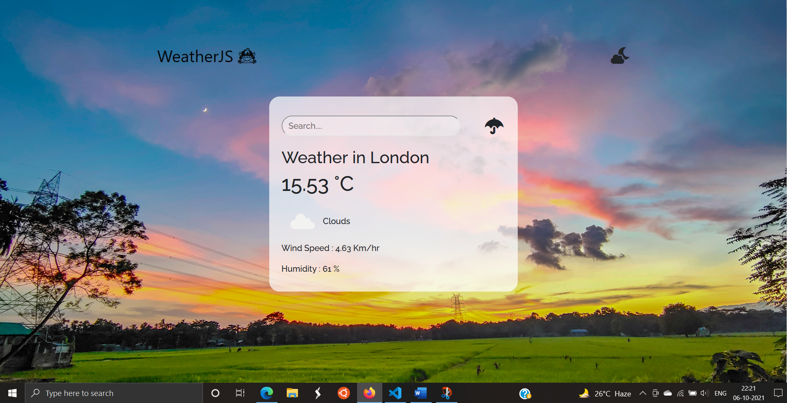

Dark-Mode available : to save ur eyes from strain

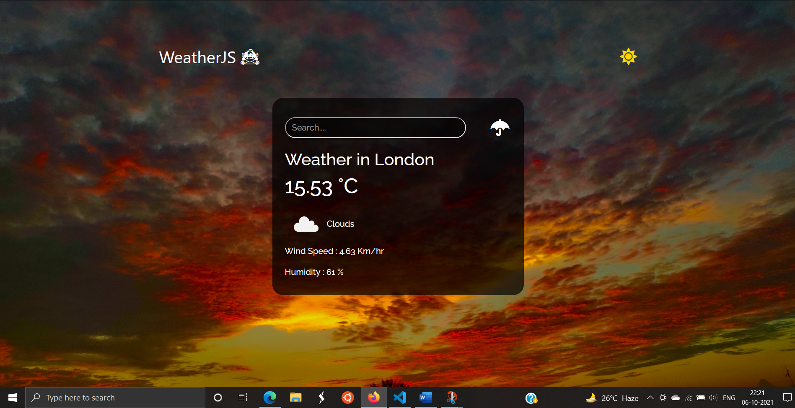

Simple conversion of celcius and farhenheit :

